A MINI PROJECT REPORT ON

“Visualization to develop project for image processing and then video processing”

SUBMITTED TO THE SAVITRIBAI PHULE PUNE UNIVERSITY,
PUNE IN THE PARTIAL FULFILLMENT OF THE REQUIREMENTS FOR THE AWARD OF THE DEGREE
OF
Computer Engineering

SUBMITTED BY
(Class – BE A, Batch – B1)
Neeti Kurulkar

UNDER THE GUIDANCE OF
Ms. Milan Shetake


COMPUTER ENGINEERING
P.E.S MODERN COLLEGE OF ENGINEERING
PUNE – 411005.
SAVITRIBAI PHULE PUNE UNIVERSITY
[2024-25]


Progressive Education Society’s
Modern College of Engineering
Shivajinagar, Pune: 411005.

CERTIFICATE

This is to certify that the following students of Computer Engineering of PES’s, Modern College of Engineering have successfully completed their mini project and design of project entitled “Visualization to develop project for image processing and then video processing” under the guidance of the course instructor. The Group Members are:
Roll Number | Name
31003 | Komal Ambhore
31018 | Tejal Dhoot
31020 | Shrey Doshi
31040 | Neeti Kurulkar
31071 | Soham Sarade

This is in partial fulfillment of the award of the degree Computer Engineering of Savitribai Phule Pune University.
Date:

Ms. Milan Shetake Prof. Dr. Mrs. S. A. Itkar
Course Instructor H.O.D Department of Computer Engineering

ACKNOWLEDGEMENT

We would like to express our sincere gratitude to Ms. Milan Shetake, our project guide, for her consistent guidance, technical insights, and constructive feedback throughout the development of our mini project, “Visualization to develop project for image processing and then video processing”. Her expertise in GPU Programming and Architecture has been instrumental in shaping the project and ensuring its successful completion.

We are also thankful to Prof. Dr. Mrs. S. A. Itkar, Head of the Department, for providing us with the academic resources and a conducive environment that enabled us to undertake and complete this project effectively.

We acknowledge the support of the Department of Computer Engineering, Progressive Education Society’s Modern College of Engineering, for facilitating access to the required tools and infrastructure during this project.

Lastly, we extend our appreciation to all faculty members and peers whose timely inputs and suggestions contributed to the improvement and refinement of our work.

Table of Contents

ABSTRACT 1
Introduction 2
1.1 Overview: 3
Objectives 5
Motivation 7
3.1 Motivation: 8
Scope 9
System 11
Architecture 11
System 13
Specifications 13
Results 16
Conclusion 19
References 21

ABSTRACT

The Visualization-Based Image and Video Processing System is a GPU-accelerated web application designed to facilitate real-time visualization, analysis, and processing of images and videos. Traditional image and video processing workflows often face challenges such as slow computation, lack of interactivity, and difficulty in visualizing results dynamically. This system leverages GPU acceleration through PyCUDA and high-level visualization using Streamlit to overcome these limitations. It is built using Python for core image and video processing, OpenCV for frame manipulation, and PyCUDA for fast parallel computations, with Streamlit providing an interactive frontend that displays processed frames and results live. Users can upload images or videos to apply edge detection, feature extraction, and other processing algorithms efficiently, while visualizing the results instantaneously. By integrating GPU computation and interactive visualization, this system accelerates development, debugging, and experimentation in computer vision projects, offering an intuitive and responsive platform for both research and practical applications.
Keywords: Image Processing, Video Processing, GPU Acceleration, PyCUDA, OpenCV, Streamlit, Visualization, Real-Time Processing, Feature Extraction, Edge Detection, Interactive Application, Python.

1.

Introduction

1.1 Overview:
In today’s digital era, efficient processing and visualization of multimedia data are essential for research, development, and real-time applications. Traditional image and video processing workflows often face challenges related to slow computation, lack of interactivity, and difficulty in interpreting results. The Visualization-Based Image and Video Processing System leverages GPU acceleration and interactive visualization to provide a fast, responsive, and user-friendly platform. Built using Python, PyCUDA, OpenCV, and Streamlit, the system allows users to process images and videos in real time, applying operations such as edge detection, feature extraction, and filtering. Each frame is processed on the GPU, ensuring high performance, while the results are displayed dynamically through an intuitive frontend. This project demonstrates how GPU-based visualization can enhance multimedia processing, offering efficiency, clarity, and interactive feedback.
1.2 Problems in Manual/Traditional Systems:
Conventional image and video processing systems rely heavily on CPU-based computation, which is slow and inefficient for large datasets or real-time applications. Manual inspection and offline processing introduce delays and make it difficult to analyze results dynamically. Many frameworks lack user-friendly visualization, making debugging, experimentation, and interpretation cumbersome. Additionally, processing large videos frame by frame without GPU acceleration can overwhelm system memory and reduce responsiveness. These limitations hinder experimentation, slow down project development, and make interactive multimedia analysis challenging.
1.3 Proposed Solution:
The proposed Visualization-Based Image and Video Processing System addresses these challenges by integrating GPU-accelerated computation with a live, interactive visualization frontend. Using PyCUDA, the system performs parallelized image and video processing, significantly reducing computation time. OpenCV handles frame manipulation and filtering, while Streamlit provides a user-friendly interface to display processed frames in real time. Users can upload images or videos, apply edge detection, feature extraction, or other processing algorithms, and immediately view results. By combining high-performance GPU computation with dynamic visualization, this system offers an efficient, interactive, and practical solution for both research and applied multimedia projects.

1.4 Use Case Scenarios:
Consider a research lab where users need to analyze and visualize multimedia data for experiments. Traditionally, image and video processing involves offline computation, frame-by-frame inspection, and manual interpretation, which is slow and error-prone. Using this GPU-accelerated visualization system, users can upload images or videos and apply processing operations such as edge detection, filtering, or feature extraction in real time. The processed results are displayed immediately through an interactive Streamlit interface, allowing users to explore and adjust parameters dynamically. Once processing is complete, outputs can be saved or shared, ensuring reproducibility and clarity. This approach can also be scaled for real-time surveillance, medical imaging analysis, or any application requiring high-performance, interactive multimedia processing.

2.

Objectives

2.1 Functional Objectives:
- Allow users to upload images and videos securely for processing and visualization.
- Enable users to apply image and video processing operations such as edge detection, filtering, and feature extraction
- Provide real-time interactive visualization of processed images and video frames.
- Ensure smooth handling of large multimedia files without crashing or data loss.
- Display processing results dynamically, allowing comparison with the original input.
- Automatically generate and allow download of processed outputs in standard formats.
- Maintain a clear log of all processing steps and parameters for reproducibility.
- Allow users to adjust processing parameters and see immediate feedback.
- Facilitate cloud or GPU-based processing to handle computation-intensive tasks efficiently.

2.2 Technical Objectives:
- Implement image and video processing logic using Python, OpenCV, and PyCUDA for GPU acceleration.
- Build an interactive frontend using Streamlit for uploading, visualizing, and controlling processing operations.
- Ensure scalability for batch processing of multiple images or video frames.
- Optimize processing algorithms to reduce runtime while maintaining accuracy.
- Deploy the application on a cloud environment (e.g., Google Colab, AWS, or Heroku) for accessibility.
- Follow security best practices for error handling, resource management, and secure file handling.

3.

Motivation

3.1 Motivation:

- The increasing demand for efficient, accurate, and interactive image and video processing tools in modern multimedia applications.
- Traditional manual image analysis is slow, error-prone, and difficult to scale for large datasets or real-time processing.
- Processing videos frame by frame on CPU can be computationally expensive and time-consuming.
- Existing tools often lack GPU acceleration or interactive visualization features, limiting user experience.
- GPU computing (e.g., via PyCUDA) offers parallel processing capabilities, making image and video analysis faster and more efficient.
- Implementing real-time processing pipelines allows dynamic visualization of effects such as edge detection, filtering, and transformations.
- The integration of interactive frontends (like Streamlit) enables users to upload, process, and visualize content instantly.
- Each processed frame or image is generated and displayed immediately, providing traceability of applied operations.
- This project demonstrates the power of GPU-accelerated computing in multimedia processing applications.
- Encourages trust in automated analysis by ensuring reproducible and verifiable processing results.
- Promotes awareness and adoption of modern image/video processing frameworks among students, researchers, and developers.
- Provides an educational opportunity to explore explore PyCUDA, OpenCV, and interactive visualization techniques..
- Showcases how acceleration and visualization can enhance understanding, analysis, and presentation of multimedia data.
- Lays the foundation for scalable, secure, and user-friendly image and video processing systems for future applications.

4.

Scope

4.1 Scope:
- The system enables users to upload and process images and videos through GPU-accelerated pipelines.
- Authorized users can securely interact with the application via a web interface (e.g., Streamlit).
- Each uploaded image or video frame is processed individually or in batches, ensuring efficient handling of large files.
- All processing steps—such as edge detection, filtering, and transformations—are performed on GPU, guaranteeing high-speed computation.
- The system provides real-time visualization of processed frames and results for immediate feedback.
- Users can view the original and processed media side by side in an interactive interface.
- GPU kernels handle all image and video processing logic — including convolution, Sobel filtering, and batch operations — without CPU bottlenecks.
- The application provides distinct views for images and videos to ensure clarity and usability of operations.
- Once processing is complete, the system automatically displays final results and allows export of processed media.
- The system ensures that intermediate and final results are preserved without data loss during processing.
- The frontend is developed using Streamlit and Python libraries, ensuring a modern, responsive, and user-friendly interface.
- The backend leverages PyCUDA, OpenCV, and Numpy for high-performance computation and accurate visual outputs.
- The application can be deployed locally, on cloud platforms, or integrated with interactive notebooks for demonstrations.
- Supports future scalability for batch video processing, advanced GPU-accelerated algorithms, and AI-based enhancements.
- The project demonstrates a real-world implementation of high-performance, interactive visualization for multimedia data processing.

5.

System

Architecture

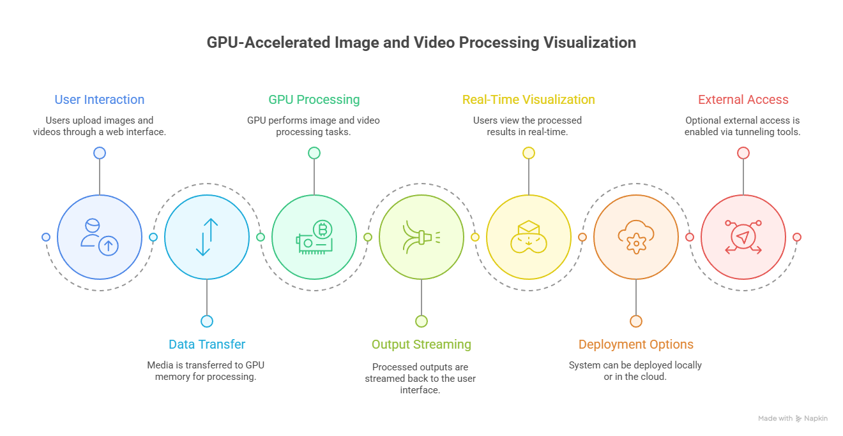

Fig. 5.1 Architecture Diagram

6.

System

Specifications

  - Hardware Requirements

Component | Minimum Specification | Recommended Specification
Processor | Intel i3 or equivalent | Intel i5/i7 or equivalent
RAM | 4 GB | 8 GB or higher
Storage | 10 GB free space | 20 GB SSD or higher
Internet | Stable broadband connection | High-speed broadband
GPU | Not required | NVIDIA GPU (e.g., Tesla T4 / RTX series) for accelerated processing

  - Software Requirements

Category | Specification
Operating System | Windows 10 / macOS / Linux
Frontend Framework | Streamlit
GPU Computing Library | PyCUDA
Programming Language | Python 3.10+
Video Processing Library | OpenCV
IDE / Editor | Visual Studio Code/ Jupyter Notebook
Cloud / Remote Access Tool | ngrok (for external visualization)
Python Package Manager | pip / conda
Optional AI / Image Models | Mistral API or similar for image analysis

7.

Results

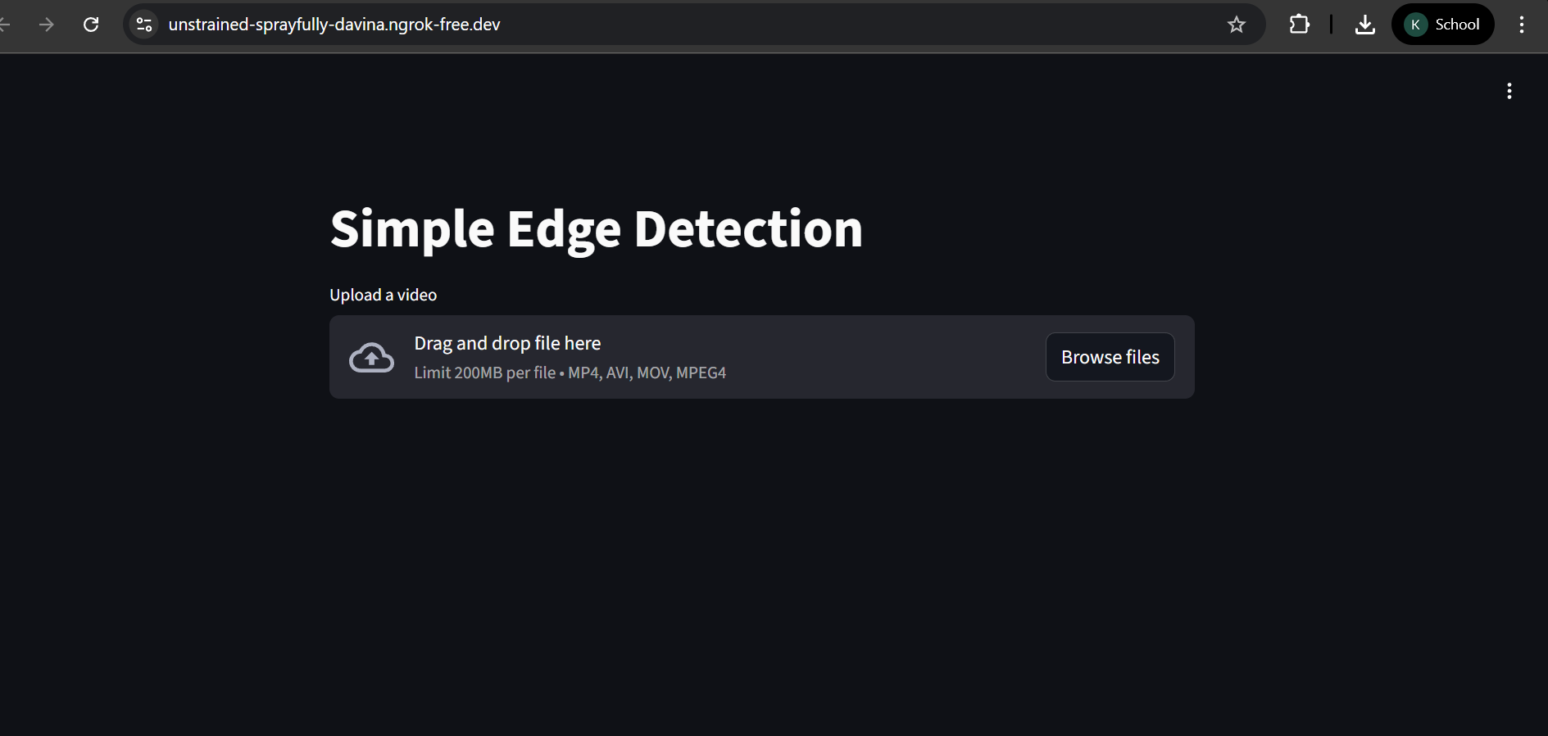
Fig: 7.1 Dashboard
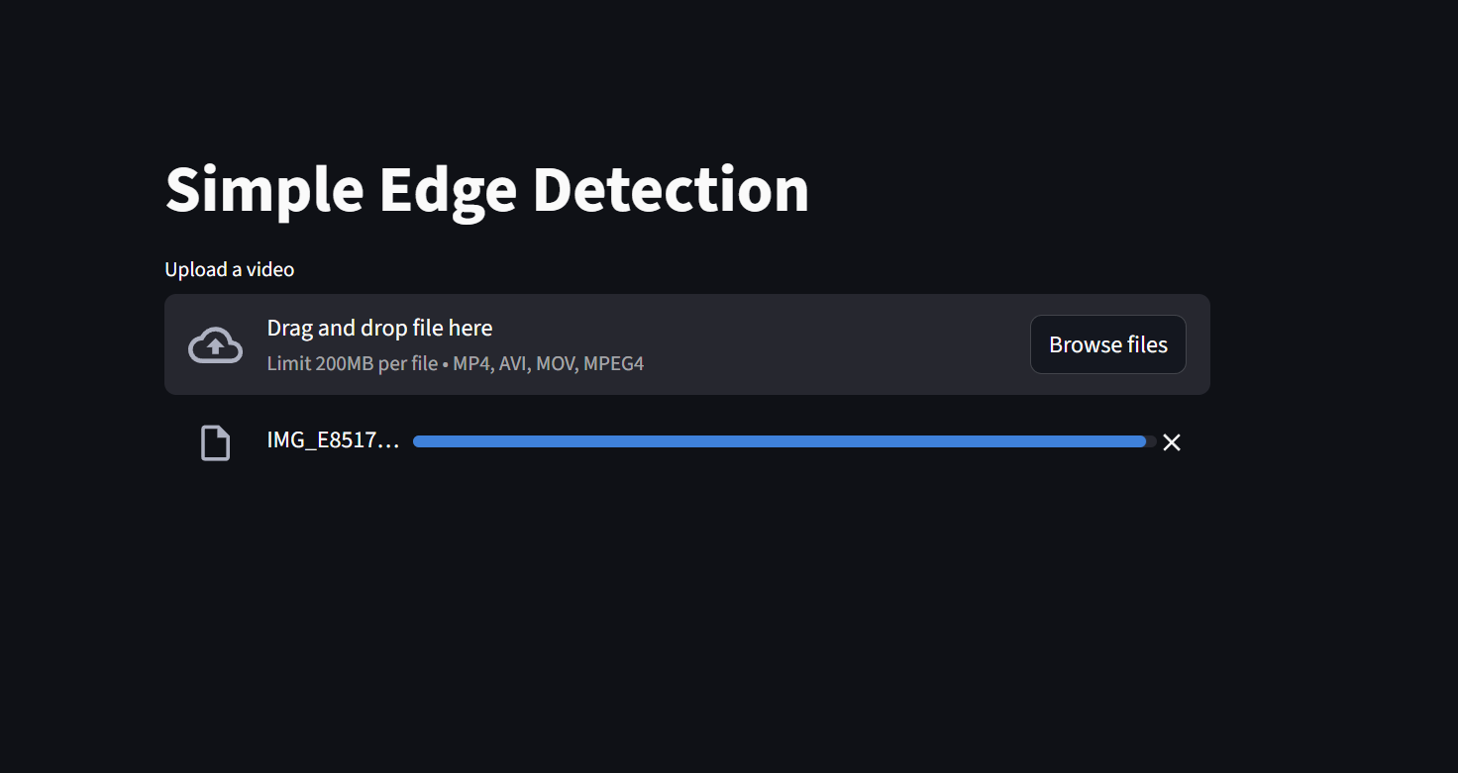
Fig. 7.2: Upload Image or Video

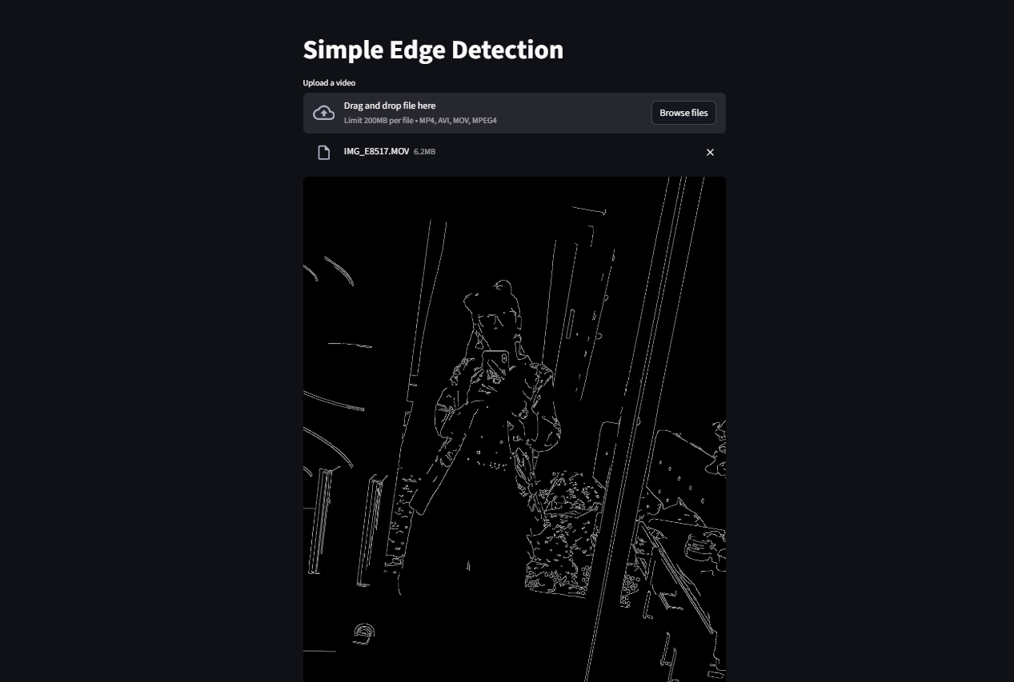
Fig: 7.3: Edges Detected in picture

8.

Conclusion

The GPU-Accelerated Image and Video Processing Visualization project provides a high-performance, interactive platform for analyzing images and videos using advanced GPU computing. By leveraging PyCUDA and OpenCV, the system enables real-time edge detection, filtering, and visualization, ensuring rapid processing of large datasets. The integration of a Streamlit frontend offers a user-friendly interface, allowing users to upload media, view processed results dynamically, and interact with GPU-accelerated computations seamlessly.
This project addresses the limitations of traditional CPU-based image processing, including slow computation, lack of real-time visualization, and inefficient handling of large video files. The application demonstrates the practical use of GPU parallel computing, Python-based visualization, and efficient memory management for high-speed processing. It also showcases the importance of batch processing, shared memory optimization, and interactive GUI design for scientific computing tasks.
Overall, this visualization system serves as a scalable prototype for real-time image and video analysis, providing a foundation for further enhancements such as integration with AI-based detection models, multi-format media support, and deployment on cloud platforms. The project reinforces hands-on experience in GPU programming, real-time visualization, and modern Python-based application development.

9.

References

- PyCUDA Documentation: https://documen.tician.de/pycuda/
- OpenCV Python Documentation: https://docs.opencv.org/
- Streamlit Documentation: https://docs.streamlit.io/
- PyNgrok Documentation: https://pyngrok.readthedocs.io/
- NVIDIA CUDA Toolkit Documentation: https://docs.nvidia.com/cuda/

